SILVERDALE PARISH COUNCIL – TENDER FOR TREE WORK 2025

You are invited to tender for all or part of work on trees owned by Silverdale Parish Council, mainly a mixture of felling or pruning. Tenders should be submitted to the Clerk to the Council by 28th February 2025 at clerk.silverdale@gmail.com
The relevant trees on all five sites are marked by a yellow dot. The four sites are; Bankwell, Burton Well Scroggs, Woodwell, and Childrens Playground.

Bankwell [ off The Row].
T125 | Common ash  (Fraxinus excelsior) | Semi-mature | Two Ash stems. Brash and arisings at base from previous tree felling. Stem one forks to two at 3 metres and has extensive established Ivy on main stem. Specimen in advanced stages of decline as a result of Ash Dieback.  One stem remains. |  | Fell
T125A | Common ash x5  (Fraxinus excelsior) | Mature | Group of five mature Ash in this area have died as a result of Ash dieback. Set back from path  yet within falling distance. Felling works undertaken. One stem remains. |  | Fell
T134A | Common ash  (Fraxinus excelsior | Mature | Group of four of poor shape and form as a result of Ash dieback. Extensive established Ivy on main stem and crown. Two from group of four felled. |  | Fell
T135A | Common ash  (Fraxinus excelsior | Semi-mature | One of pair felled following 2023 survey. |  | Fell

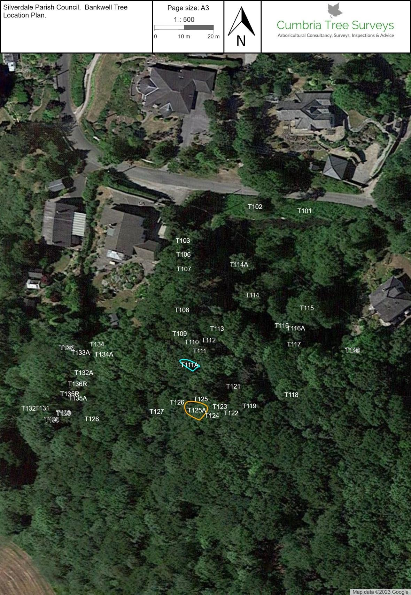

Burton Well Scroggs [off Bottoms Lane]
T199B | Common Ash  (Fraxinus excelsior) | Semi-Mature | New to 2024 survey. Specimen at boundary with caravan to base within falling distance. Specimen in decline with evidence of previous pruning. Upper stems with bark necrosis and decay developing. Low voltage overhead electricity line to the north. | Poor | Fell.

Woodwell [ Woodwell Lane off Lindeth Road]
T047 | Common ash  (Fraxinus excelsior | Mature | Substantial mature specimen. Deadwood in upper crown over seating area. No discernible evidence of Ash dieback at time of survey. |  | Prune to crown clean and remove deadwood

Childrens Playground [off Cove Road]
T257 | Sycamore  (Acer pseudoplatanus | Young | Specimen at immediate base of boundary wall with crown over boundary. As the specimen continues to develop, this is likely to cause pressure loadings to the wall and subsequent damage may occur. |  | Fell

This tree is in the woods at the back of the playground.

All risings to be tidied and left on site. Any questions feel free to contact Cllr terry Bond at; terry.bond@silverdale-pc-lancs.gov.uk

