

Silverdale
Community Emergency Plan
NON-RESTRICTED

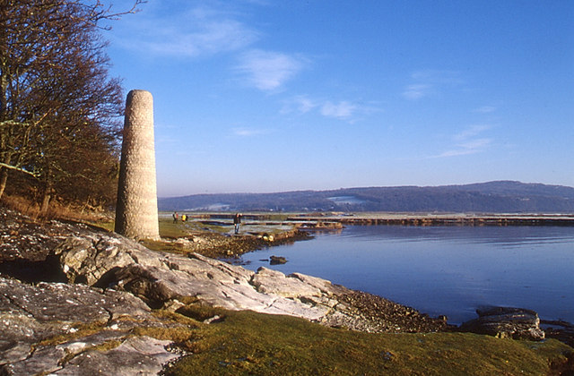

PUBLIC VERSION

14th June 2024

WHAT IS A MAJOR EMERGENCY?
The Cabinet Office defines a major emergency as:“Any event or circumstance (happening with or without warning) that causes or threatens death or injury, disruption to the community, or damage to property or to the environment on such a scale that the effects cannot be dealt with by the Emergency Services, local authorities and other organisations as part of their normal day-to-day activities.”
CONTENTS

Section | Details | Page
Rationale | Why do we need a Plan? | 3
 | Plan Ownership | 3
 | Distribution /Annual Review / Record of Amendments | 4
1 Information | Silverdale Village & Map | 5
2 The Plan | Intention & Structure | 6
3 Method | Activation of The Plan | 6
 | Initial Actions for Emergency Coordinators | 7
 | Threats and Mitigation | 7
 | Guidelines for Managing an Emergency | 8
 | Roles of Agencies in an Emergency | 8-9
 | Preparation | 10
4 Administration | Administration | 10
Appendix A | Contact Details for Silverdale Emergency Plan Co-Ordinators | 11-12
Appendix B | Contact Details for External Organisations and Utilities | 12-14
Appendix C | Equipment Available to Support the Emergency Plan | 14-15
Appendix D | Gaining access to the Gaskell Hall and Emergency Equipment | 15
Appendix E | Emergency Generator: Start-Up and Shut-Down Procedure | 16-20
Appendix F | Use of Diesel Generator to Provide Supplies to the Gaskell Hall | 20-21
Appendix G | Use of Communication Equipment | 22
Appendix H | Emergency Plan Log Sheet | 23
Appendix J | Emergency Plan Task Sheet | 24
Appendix K | Met Office Weather Warnings | 25-26
Appendix L | PC Service and Maintenance Schedule of Emergency Equipment | 26
Appendix M (R) | Residents who have Volunteered their Services | 27
Appendix N (R)) | Residents requesting Transportation to Gaskell Hall | 27
Appendix P | Procedure in Gathering Information | 28
RATIONALE

Why do we need a Plan?
The Silverdale Community Emergency Plan is to provide initial response to extreme circumstances which may fall outside of the remit of the Emergency Services, or which may prevent the Emergency Services reaching Silverdale. In such circumstances the initial response will rely on the residents of Silverdale. The plan describes how such an initial response will be co-ordinated.

Members of the Silverdale Parish Council will carry out the role of Emergency Plan Administrators who are responsible for the servicing of the Emergency Plan document. Councillors will also undertake the roles of Emergency Plan Co-ordinators. Village residents who would like to assist, are all welcome as team members.

The Emergency Plan will not be used to replace the responsibilities of the Emergency Services, local authorities, utilities, or other such organisations. In the event of an emergency situation, the first action should always be to contact the appropriate emergency service.

Plan Ownership

Plan Owner | Silverdale Parish Council
Administrator | Denise Challenor - Clerk, Silverdale Parish Council or any Parish Councillor
Version | Coordinators & Administrators Version Public 1.4
Date | 14.6.24

The Plan Administrator is responsible for ensuring the plan remains up to date, serviced and for the distribution of hard and digital copies of the plan.

The Plan Administrator and Emergency Coordinators will keep a hard copy of the Emergency Plan. A hard copy will also be secured in the Gaskell Hall. The Lancaster City Council Resilience Officer (Kirstie Banks-Lyon, Morecambe Town Hall) will also be provided with a hard and digital copy.

The Resilience Officer at Lancaster City Council will ensure that electronic versions of this plan are circulated appropriately within the council and forwarded to:
- Lancashire Constabulary
- Lancashire Fire and Rescue Service
- Northwest Ambulance Service
- Lancashire County Council Emergency Planning
- Environment Agency
- Any other appropriate responder agency.

DISTRIBUTION RECORD – THIS VERSION (REVISED FROM 2021)

Name | Organisation | Date Sent
Resilience Officer Kirstie Banks Lyon * | Lancaster City Council | June 2024
All Councillors & Clerks * | Silverdale Parish Council | June 2024
Silverdale Library |  | June 2024
The Gaskell Hall |  | June 2024
St John’s Church Parish Rooms |  | June 2024
Silverdale Primary School |  | June 2024
The Village Institute |  | June 2024
Philippa Williamson | Lancashire County Council | June 2024
Alan Greenwell | Lancaster City Council | June 2024
^{*Restricted Version}

ANNUAL REVIEW

Date | Reviewed by | Signature
April 2022
October 2022 | Liz Unsworth | DONE
July 2023 | Liz Unsworth | DONE
June 2024 | Liz Unsworth | DONE

RECORD OF AMENDMENTS

Revision number | Date | Pages | Amended by
Rev 2 | October 2022 | FP-8, 11-12, 15-22, 25-26, 28 | Liz Unsworth
Rev 3 | July 2023 | 1,2,3,4,11,12 | Liz Unsworth
Rev 4 | June 2024 | 1-4, 11-12 | Liz Unsworth

1. INFORMATION

Silverdale Village
Silverdale is a small but thriving village in Lancashire, situated on the border with Cumbria and facing westwards into Morecambe Bay. It is a popular retirement area and also an area which attracts many tourists and holidaymakers. It is located within one of Britain’s smallest Area of Outstanding Natural Beauty – the Arnside/Silverdale AONB.

The community of around 1,500 residents is well served with small, friendly shops and enjoys excellent services provided by a doctor’s surgery, village primary school, library, two village halls, two churches, a fire station, community policing supported by the Neighbourhood Watch group and the Parish Council. There are several static caravan and RV holiday parks located in Silverdale and on its border with Cumbria. During holiday periods, visitors can increase the population within the area by c.1,000.
Map of the Civil Parish of Silverdale

2. INTENTION & STRUCTURE OF THE PLAN

Intention
The aim of The Emergency Plan is to provide a single source of local information to improve community resilience and provide an effective initial response in an emergency situation.

The specific emergency situations covered by the plan include:

- Significant utility failure (Electricity/Water/Gas)
- Predicted severe or extreme weather (high winds etc.)
- Any other widespread incident
- Medical Emergency
- Fire.

Although Silverdale escaped the impact of flooding and loss of electrical supplies caused by storm Desmond in December 2015, the Parish Council believes there is significant benefit in having an Emergency Plan to deal with the postulated emergency situations detailed above.

Structure
The plan provides a framework for listing contact details, responsibilities, and information about resources. It is intended to be of help in taking action at the onset of an emergency.

It is expected that in the event of an emergency situation that one of the Emergency Plan Coordinators will take the lead role in activating the arrangements detailed in the Emergency Plan.

The plan itself has the guidelines for dealing with an emergency situation. There are several appendices which provide supporting documentation.

3. METHOD

Activation of the Plan

Emergency Coordinators will meet to consider activating the plan following an activation trigger such as:

- Loss of utilities such as water, gas, electricity, telephone.
- Severe weather warning from MET office.
- When Emergency Services contact an Emergency Coordinator for support.
- When Lancaster City Council or Lancashire County Council Emergency Planning Officer contacts an Emergency Coordinator.

Note: Surface water flooding should be considered as this could be a major problem e.g., if the New Road culvert is blocked.

Initial Actions for Emergency Coordinators

1 | If an emergency arises gather factual information.  The emergency coordinators should first evaluate the potential emergency situation and consider if the Emergency Plan needs to be activated (See Appendix P).
2 | Set up Emergency Centre in Gaskell Hall. Nominate one of the coordinators as lead.

Threats and Mitigation

Threat | Potential Impact | Mitigation
Loss of electricity supply | Unable to keep warm and prepare hot food. | Provide emergency generation at the Gaskell Hall which will allow the operation of the heating system and limited microwave facilities.
Loss of gas supply | Unable to keep warm and prepare hot food. | Provide heating at the Gaskell Hall and cooking facilities.
Loss of telephone service | Unable to access Emergency Services or other support services. | Provide communication at Gaskell Hall or wi-fi access.
Loss and/or contamination of water supply | Vulnerable unable to access clean water. | Provide coordination for response and support to United Utilities.
Extreme weather | Damage to property. | Provide temporary accommodation at Gaskell Hall.
Major fire | Damage to property. | Provide temporary accommodation at Gaskell Hall.  Provide assistance to Emergency Services.
Transport accident | Damage to property. Release of hazardous substances. | Provide temporary accommodation at Gaskell Hall.  Provide assistance prior to Emergency Services arriving.
Missing Person | Could be life threatening to the individual. | Provide support to Emergency Services. Coordinate local response.

Guidelines for Managing an Emergency
Below are some prompts for response in the event of an emergency. The nature of the emergency will determine the response but due to the number of variables it is not possible to produce an exhaustive list of prescriptive procedures.

The Appendices to the Emergency Plan provide details of the equipment available, instructions on use and other information of use to the Emergency Coordinator.

Actions for the coordinators in the event of an emergency:

- Identify any actions/tasks that need to be addressed immediately.
- Assess the full impact of the emergency on the village. This may require observations around the village.
- Establish communications with the relevant outside organisations.
- Once the situation is understood, place actions and tasks on team members as required. Tasks should be detailed on Task sheets and recorded on the Log sheet.
- The whiteboard can be divided into different sections and used by the Coordinator to detail focus areas, actions and assigned tasks.
- The flipchart can be used to list future actions or reminders.
- Provide welfare for residents if required (e.g., warmth, microwave facilities for heating food, boiling water if required).
- Provide updates to residents who attend the Gaskell Hall.
- Arrange to transport to the Gaskell Hall residents who have previously registered a request for this in the event of an emergency.

Roles of Agencies in an Emergency
Police - The Lancashire Constabulary is responsible for the coordination of all other agencies at the scene of any emergency incident. The police also investigate any possible criminal aspects of any incident.

The Lancashire Fire & Rescue Service is responsible for firefighting and rescue. They are comprehensively equipped with search and rescue equipment, including specialist equipment for rescue from collapsed buildings. They also have access to high volume pumping equipment and may be asked to assist in flooding incidents. Many crew members are trained to be first responders at medical emergencies too.

The Northwest Ambulance Service is responsible for providing First Aid to casualties at the scene of any emergency incident and transport of casualties to hospital. At any multi-agency incident, the Ambulance Service is the ‘gateway’ organisation to the wider National Health Service meaning that, in an emergency, other agencies wishing to access any health organisation will initially do so through the Ambulance Service.

HM Coastguard, whilst primarily coordinating the response to coastal and offshore incidents, also has access to resources that can assist in inland emergencies, particularly flooding.

The University Hospitals of Morecambe Bay NHS Trust has an emergency plan for the treatment of casualties at local hospitals and further afield. This includes the deployment of a Hospital Mobile Emergency Team into the community.

The Environment Agency has a particular responsibility for flood forecasting and warning and the identification of flood risk areas. It is also involved in managing water pollution emergencies.

Lancaster City Council supports the Emergency Services at an incident by the provision of a Duty Emergency Incident Officer, Evacuation Rest Centres, waste clearing operations, environmental protection advice along with engineering and building control services.

Lancashire County Council also has an Emergency Planning Duty Officer and also provides countywide services such as Education and Adult & Children’s (Social) Services.

Voluntary Organisations offering their various skills to the communities of Lancashire in times of emergency include:

- St. John Ambulance
- British Red Cross
- Salvation Army
- Raynet (Radio Amateurs)
- Faith Groups
- Mountain Rescue Teams.

These voluntary organisations are coordinated in Lancashire by the County Council Emergency Planning Service and the initial contact point for any of the above organisations must be the County Emergency Planning Duty Officer, who can be contacted by the Lancaster City Council Duty Emergency Incident Officer or any of the ‘blue light’ services.

Agencies supporting these organisations include:

- Electricity Northwest - provides specialised assistance concerning electricity supplies; to continue to supply electricity; to liaise with other organisations for the provision of emergency supplies; and the disconnection of cables that constitute a danger to life and property.

- United Utilities - deals with the maintenance of water supplies and sewage disposal arrangements, repairs to water mains and the availability of emergency water supplies in an incident.

Preparation
Residents are encouraged to keep themselves informed and be aware of weather conditions that may result in flooding or other disruption. Sources of this information include:

Met Office – severe weather warning forecasts.

Environment Agency – Flood Alert notifications for the Lower Lune and Conder catchment. These include automated messages to landlines, mobile telephones, tweets and e-mails for residents and businesses registered for the Flood Warning Area scheme. EA also provides Flood Alert and Warning notifications for the coast at North Morecambe Bay, which includes Silverdale.

Local radio – broadcasts of Environment Agency flood watches and weather warnings.

Silverdale Parish Council - media services.

Residents of outlying areas are encouraged to maintain emergency packs and in periods of good weather should check that equipment is working correctly, batteries charged, and essential supplies restocked. Where flood defence equipment is kept in readiness, or has been installed, it should be maintained including oiling/greasing of mechanisms. Whilst sandbags are only of limited use, if they are held, they should be checked to confirm they are safe and dry. Drainage channels should be checked and if necessary cleaned.

4.ADMINISTRATION

Emergency Plan
This plan has been produced by the community in association with the Resilience Officer at Lancaster City Council. It has been quality assured by Lancashire County Council Emergency Planning Service and the Environment Agency. The plan owner and other Community Contacts are responsible for keeping the plan up to date. The plan will be reviewed at least annually or after any activation.

The plan is available for any member of the community to read, and the planners welcome any observations on how it may be improved.

The Emergency Plan will be posted on the Silverdale Parish Council website:
http://www.silverdale-pc-lancs.gov.uk

Appendix A – Contact Details for Silverdale Emergency Plan Coordinators
NAME | Terry Bond
ROLE | Emergency Plan Coordinator
24 HOUR CONTACT | 01524 702693
EMAIL | terry.bond@silverdale-pc-lancs.gov.uk
ADDRESS | 6 Bottoms Lane, LA5 0TN

NAME | John Bennett
ROLE | Emergency Plan Coordinator
24 HOUR CONTACT | 07759 154148
EMAIL | john.bennett@silverdale-pc-lancs.gov.uk
ADDRESS | 3 The Green, LA5 0TJ

NAME | Tony Houghton
ROLE | Emergency Plan Coordinator
24 HOUR CONTACT | 01524 701416
EMAIL | tony.houghton@silverdale-pc-lancs.gov.uk
ADDRESS | 16 Shore Road, LA5 0TS

NAME | Keith Reed
ROLE | Emergency Plan Coordinator
24 HOUR CONTACT | 01524 702401
EMAIL | keith.reed@silverdale-pc-lancs.gov.uk
ADDRESS | High Bank Hse, Lindeth Road, LA5 0TT

NAME | Sarah Fishwick
ROLE | Emergency Plan Coordinator
24 HOUR CONTACT | 01524 701592
EMAIL | sarah.fishwick@silverdale-pc-lancs.gov.uk
ADDRESS | 52 Emesgate Lane, LA5 0RF

NAME | Jenny Webster
ROLE | Emergency Plan Coordinator
24 HOUR CONTACT | 07747 722954
EMAIL | jenny.webster@silverdale-pc-lancs.gov.uk
ADDRESS | 5 Levens Way, LA5 0TG

NAME | Liz Unsworth
ROLE | Emergency Plan Coordinator
24 HOUR CONTACT | 01 524 805664
EMAIL | liz.unsworth@silverdale-pc-lancs.gov.uk
ADDRESS | 14 Levens Way, LA5 0TG

NAME | Ian Fisher
ROLE | Emergency Plan Coordinator
24 HOUR CONTACT | 01 524 702594
EMAIL | Ian.fisher@silverdale-pc-lancs.gov.uk
ADDRESS | 39 Emesgate Lane, LA5 0RF

Appendix B - Contact Details for External Organisations and Utilities

Communication Type | Contact | Location
Emergency Services | 999 (24hr)
Lancashire Police | 101 (non-urgent) | lancashire.police.uk/
Lancashire Police HQ | 01772 614444 | lancashire.police.uk/
Lancaster & Morecambe Police Stations | 101 (24hr) or 0845 125 3545 | Lancaster & Morecambe
Neighbourhood Police | 01524 596985 | Morecambe
Lancaster Fire Station | 01524 60193 | Lancaster
Lancashire Fire & Rescue | 01772 862545 | lancsfirerescue.org.uk/Pages/home
Lancaster City Council | 01524 582000 (Daytime)  01524 67099 (Out of hours) | lancaster.gov.uk/environmental-health/emergency-planning/emergency-contact-details  Lancaster/Morecambe
Lancashire County Council | 0330 1236701  0300 053 0000 | lancashire.gov.uk/  Preston
Lancashire  Environmental, Health, Emergency Planning |  | http://new.lancashire.gov.uk  then search for emergency.
Environment Agency – Incident Hotline | 0800 80 70 60 (24hr)  03708 506 506 | www.environment-agency.gov.uk
Royal Lancaster Infirmary | 01524 65944 | nhs.uk/Services/Hospitals/Overview/DefaultView.aspx?id=2122
Coastguard | 999 | gov.uk/government/organisations/maritime-and-coastguard-agency
National Grid - Electricity | 0800 056 8090 | www2.nationalgrid.com/uk/our-company/electricity/
National Grid – Gas | 0800 111 999 (24hr) | www2.nationalgrid.com/UK/Our-company/Gas/
Electricity Northwest | 0800 195 4141 | enwl.co.uk/
Electricity Information and Reporting Number | 105
British Telecom | 0800 800 151 (24hr) | www.bt.com
Heysham 1 Power Station | 01524 853131 (24hr) | edfenergy.com/energy/power-stations/heysham-1
Heysham 2 Power Station | 01524 863863 (24hr) | edfenergy.com/energy/power-stations/heysham-2
Highways Agency | 0300 123 5000 (24hr) | highways.gov.uk/traffic-information/
United Utilities - water | 03456 723 723 | unitedutilities.com/
Coastal Medical Group | 01524 511999 | coastalmedicalgroup.co.uk/contact1.aspx
NHS Direct | 111 (24hr) | nhs.uk/NHSEngland/AboutNHSservices/Emergencyandurgentcareservices/Pages/NHS-111
Heart North Lancs and Cumbria Radio | 01524 895000 or 895969  TEXT 82122 - STATION | FM 96.9 or DAB  www.heart.co.uk/northlancs/
BBC Radio Lancashire | 0800 7833583 | FM 95.5, 103.9. 104.5 or DAB lancashire@bbc.co.uk
RSPCA | Contact via Duty County Emergency Planning Officer 0300 123 4999 / 555 | www.rspca.org.uk
Radio - RAYNET  Contact via Duty County Emergency Planning Officer | North Lancashire,  Paul Woodburn  07721 457257 | www.raynet-uk.net  Silverdale
Radio - RAYNET  Contact via Duty County Emergency Planning Officer | RAYNET – Northwest,  Roger Alexander  03030 401080  07739 370001 | www.raynet-uk.net
North West 4x4 Responders |  | www.nw4x4responders.co.uk
British Red Cross | Contact via Duty County Emergency Planning Officer 0844 871 11 11 | www.redcross.org.uk
WRVS | Contact via Duty County Emergency Planning Officer 0845 601 4670 | www.wrvs.org.uk
St John Ambulance | 0870 104 950 | www.sja.org.uk
Emergency Alerts |  | gov.uk/government/publications/mobile-alerting-trials-for-public-emergencies/public-emergency-alerts-mobile-alerting-trials
Met Office | 0370 900 0100 | www.metoffice.gov.uk
Salvation Army | Contact via Duty County Emergency Planning Officer | www.salvationarmy.org.uk/
Bowland & Pennine Mountain Rescue | Contact via Force Incident Manager, Lancashire Police HQ | www.bowlandpenninemrt.org.uk/about.htm
Bay Search & Rescue | Contact via Force Incident Manager, Lancashire Police HQ or HM Coastguard Operations Centre
Northwest Air Ambulance | 0800 587 4570 | https://nwaa.net/ enquiries@nwaa.net

Appendix C – Equipment Available to Support the Emergency Plan

- A 6kw long-run diesel generator is located adjacent to the external stairs to the Gaskell Hall. There are an additional 3 x 20 litre cans of diesel fuel inside the generator cabinet. Full power running in the fuel available will allow for at least 48 hours operation.

- Eight pairs of two-way radios with rechargeable batteries. Radios have a 10 km communication range. In the event of a declared emergency these will be issued to attending Coordinators

- 1 x DAB radio

- 4 x wind-up torches

- 2 x hand torches with spare batteries

- 2 x rechargeable hand lanterns

- 1 x head torch

- 1 x whiteboard with whiteboard pens

- 1 x flipchart with pens

- Large scale local maps

- Emergency Plan Log sheets

- Emergency Plan Task sheets

All this equipment is located in the anteroom of the projection room on the first floor of the Gaskell Hall. Arrangements have been made for all batteries to be recharged at regular intervals.

Appendix D – Gaining Access to the Gaskell Hall and Emergency Equipment

1 | A personal torch will be required by all coordinators if there is a loss of electricity supply
2 | 24-hour emergency access to the Gaskell Hall has been arranged for Coordinators.
3 | The keys for access to the Emergency Plan equipment are in a labelled key safe. This is located in the storage room adjacent to the table storeroom next to the ground floor kitchen.
4 | Obtain the key for the door to the stairs. The light switch is at the bottom of the stairs.
5 | At the top of the stairs on the left-hand side is the meter room. Access is required if there is a loss of electrical supplies.
6 | At the top of the stairs on the right-hand side is the lighting room which is locked using a hasp and padlock.  Through the lighting room is the storeroom which is also locked using a hasp and padlock.
7 | In the storeroom is the emergency equipment cabinet.  The whiteboard & stand and flipcharts & stands are stored in the storeroom.

Appendix E – Emergency Generator: Start-Up and Shut Down Procedure
1 | Obtain the generator cabinet keys from the Emergency Plan key safe (Appendix D).  The generator cabinet is located outside the Gaskell Hall next to the steps up to the Green Room.  The cabinet is locked using a yale type lock and a padlock.
2 | Open the right-hand door of the cabinet and release the spring-loaded catches at the top and bottom of the left-hand door and open the door. Release the spring-loaded catch on the cabinet lid and open the lid.  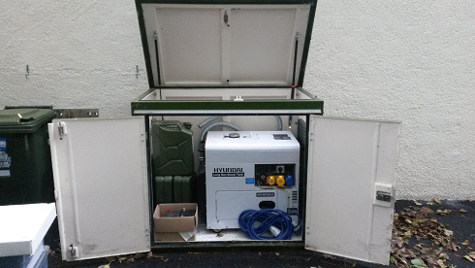  Remove the jerry cans of diesel from the cabinet and place to the right-hand side of the cabinet.
3 | Open the small hatch on the left-hand side panel of the cabinet and run the exhaust pipe through it and across the bottom set of hooks. Point the exhaust down. Remove the dummy plug from the socket on the wall and plug in the 240v extension lead. Hook up the extension lead coil and run the lead across the upper hooks. Run the lead through the hatch.  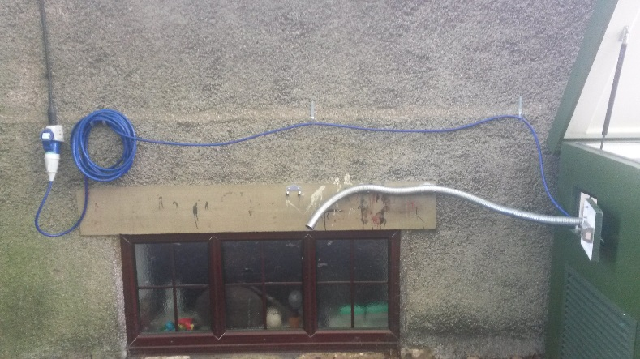
4 | CAUTION: ENSURE THAT THE EXHAUST PIPE AND EXTENSION LEAD ARE KEPT SEPARATED.  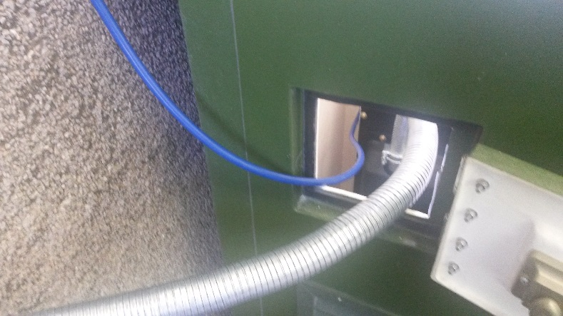
5 | Run the lead across the back of the generator and plug into the blue 240v socket labelled X3 on the front of the generator.  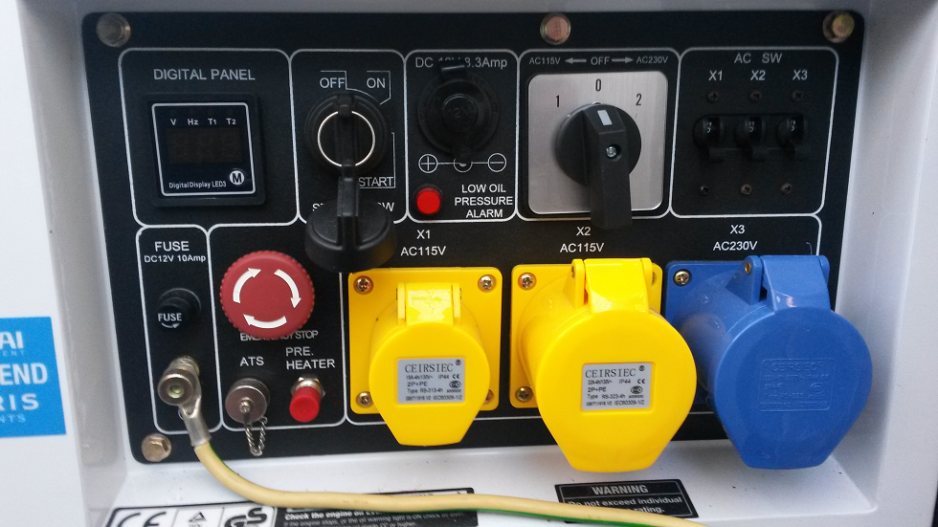
6 | Open the generator compartment door and select the lever to the RUN position.  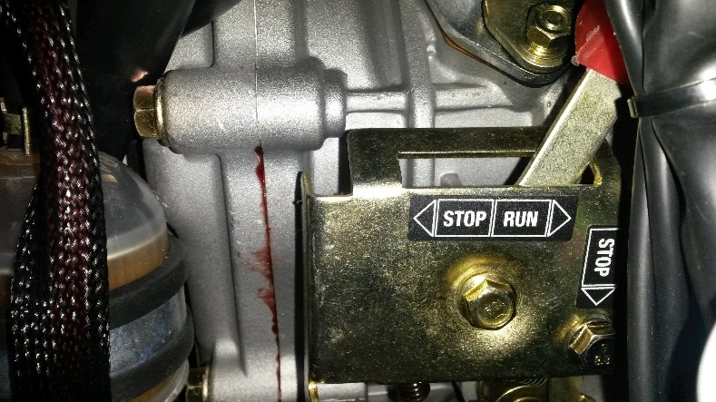
7 | Check the diesel tank is full (coarse gauge on the top of the tank).
8 | Check engine oil level using the dipstick below the stop/run lever.
9 | On the generator control panel ensure that the emergency stop pushbutton is reset. Use the key switch to start the generator.
10 | Select the AC output selector switch to position 2 and switch on circuit breaker X3. The digital voltage indicator should indicate 230v.  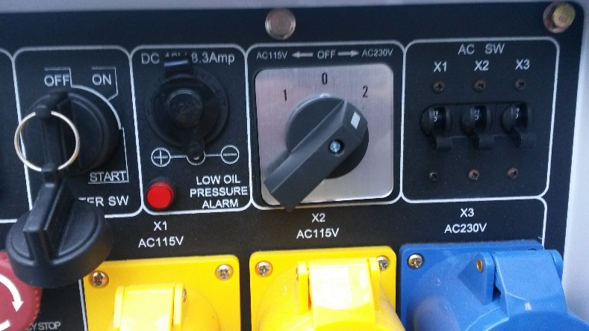
11 | The generator should be capable of running for 24 hours with a tank full of diesel depending on load. However, the tank level should be checked at initial start-up before nightfall to avoid having to refuel during hours of darkness. NB: The engine must be shutdown before refuelling.  In the cabinet there is a spout extension to connect to the jerry cans, a funnel, protective clothing, and oil absorbent pads to enable the refilling of the generator diesel tank.  There is a headtorch in the emergency equipment cabinet if required.
 | A TORCH WILL BE REQUIRED FOR THE FOLLOWING OPERATIONS:
12 | In the kitchens ensure that the cookers, kettles, water heaters and sockets are all switched off.
13 | Access the meter room at the top of the stairs (see Appendix D).
14 | On the lighting and small power distribution board switch off the circuit breakers 3, 4, 5, 7 & 8. This will isolate toilet water heaters, toilet hand driers and main entrance overdoor heater.  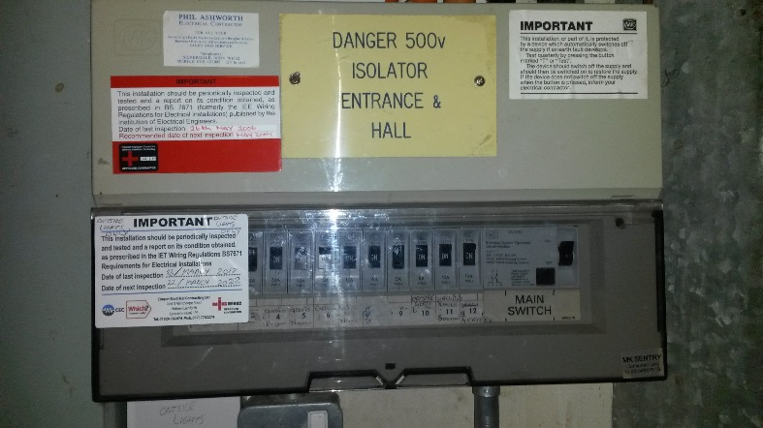
15 | Switch off the isolator which supplies the stage lighting.  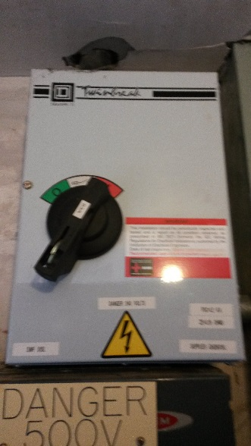
16 | Switch the main supply changeover switch from MAINS to GEN.  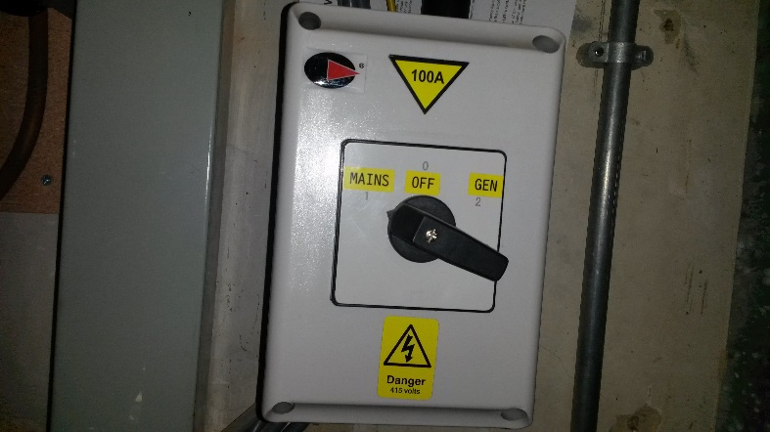  The generator is now supplying electricity to the Gaskell Hall.

Appendix F - Use of Diesel Generator to Provide Supplies to the Gaskell Hall

17 | On the stairs from the upstairs kitchen to the Main Hall is the dimmer switch for the centre lights for the Main Hall.  DO NOT SWITCH ON THE PENDANT LIGHTS SINCE THEY FLICKER WHEN SUPPLIED BY THE GENERATOR.  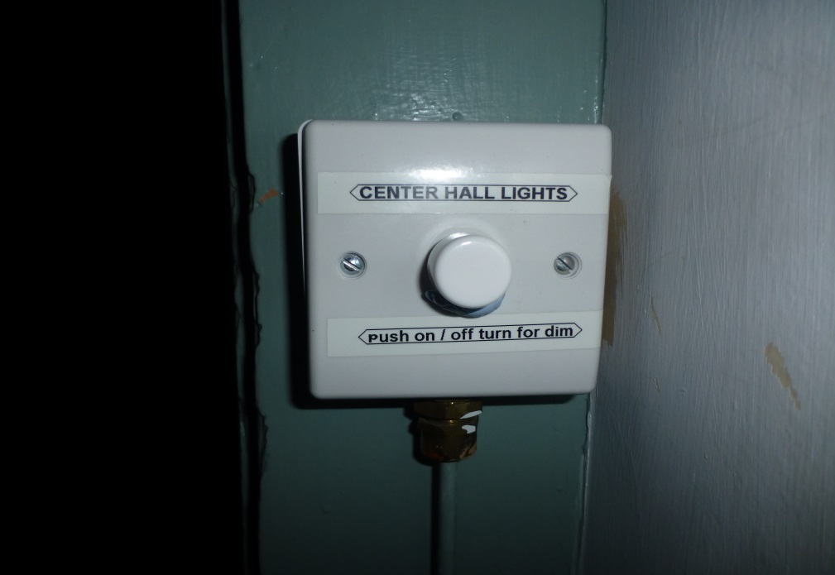
18 | There are stickers in the Emergency Equipment cabinet which can be put on sockets to prevent unauthorised use.
19 | The generator is rated at 6kw and will support the following:  - Lighting  - The oil-fired central heating system.  - One (but not both) of the two water boilers in the kitchens. Alternatively, one kettle can be used instead.  - One microwave.  - One fridge.  - Small power items such as chargers, Wi-Fi hubs, radios etc.
20 | WHEN THE MAINS ELECTRICITY HAS BEEN RESTORED, SWITCH THE MAIN SUPPLY CHANGEOVER SWITCH FROM GEN TO MAINS (SEE STEP 16)
21 | Switch the generator AC output switch from 2 to 0.  Switch the key switch from ON to OFF.  CAUTION: If this is not done the battery will drain.  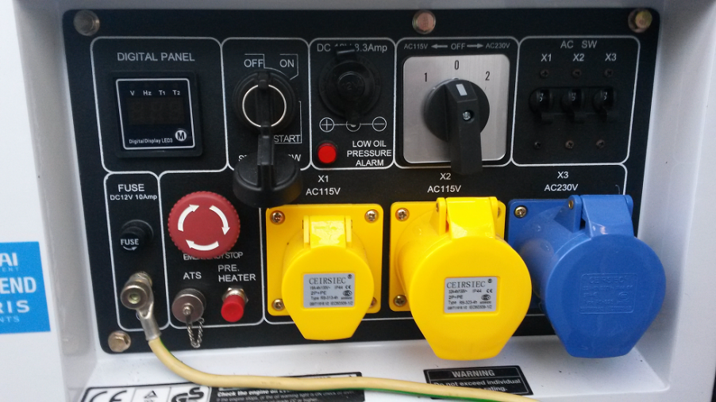
22 | Open the generator compartment and operate the STOP latch. This will trip the STOP/RUN lever to the STOP position. (The generator can also be shutdown using this method).  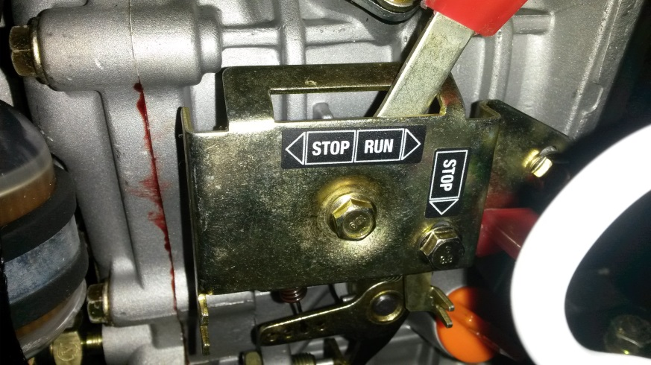
Appendix G – Use of Communication Equipment
The following communication equipment is available:
- Wi-Fi Connection
The Wi-Fi network name is: TNCAPEDE1F7. The password is: Silverdale
- Two-Way Radios
The two-way radios are set up to enable all 8 radios to be used on the same channel. They have re-chargeable batteries.
The radios are designated RADIO 1 to RADIO 8.
Switch on the radios using the rotary on/off/volume knob on the top of the radio.
The transmit button is on the left-hand side. The person transmitting should use their own radio identification first (e.g., “RADIO 1 to RADIO 4 come in Joe”).
The phonetic alphabet (listed below) can be used if clarification is required such as spelling a name, medication, a registration number etc.
Letter: | Code Word: | Pronunciation:
A | Alpha | Al fah
B | Bravo | Brah Voh
C | Charlie | Char Lee
D | Delta | Dell Tah
E | Echo | Eck Oh
F | Foxtrot | Foks Trot
G | Golf | Golf
H | Hotel | Hoh Tell
I | India | In Dee Ah
J | Juliett | Jew Lee Ett
K | Kilo | Key Loh
L | Lima | Lee Mah
M | Mike | Mike
N | November | No Vem Ber
O | Oscar | Oss Car
P | Papa | Pah Pah
Q | Quebec | Keh Beck
R | Romeo | Row Me Oh
S | Sierra | See Air Ah
T | Tango | Tang Go
U | Uniform | You Nee Form
V | Victor | Vik Tah
W | Whiskey | Wiss Key
X | X Ray | Ecks Ray
Y | Yankee | Yang Key
Z | Zulu | Zoo Loo

Appendix H – Emergency Plan Log Sheet

Log Sheet Number: ………………………….

Emergency Plan Coordinator…………………………………………

Time | Action/Event | Who | Completed

Appendix J – Emergency Plan Task Sheet

Task Sheet Number: ………………………….

Assigned To …………………………………………

Time | Task | Completed

Appendix K – Met Office Weather Warnings

Weather Warnings Guide
The Met Office warns the public and Emergency Services of severe or hazardous weather which has the potential to cause damage, widespread disruption and/or danger to life through its National Severe Weather Warning Service. This includes warnings about rain, snow, wind fog and ice.
These warnings are given a colour depending on a combination of both the likelihood of the event happening and the impact the conditions may have.
The basic messages associated with each of the colours are:
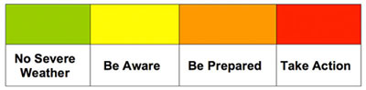
The basic message associated with each warning level is:
Likelihood
High | - You may need to take action as we are expecting ...  - There will be ...
Medium | - We should be prepared for ...  - There is likely to be ...
Low | - Be aware of the potential/possibility ...  - There is the small chance of ...
Very Low | - Be aware that there is a very small risk of ...

What the colours mean

- Yellow: Be aware.

Severe weather is possible over the next few days and could affect you. Yellow means that you should plan ahead thinking about possible travel delays, or the disruption of your day-to-day activities. The Met Office is monitoring the developing weather situation and Yellow means keep an eye on the latest forecast and be aware that the weather may change or worsen, leading to disruption of your plans in the next few days.

- Amber: Be prepared.

There is an increased likelihood of bad weather affecting you, which could potentially disrupt your plans and possibly cause travel delays, road and rail closures, interruption to power and the potential risk to life and property. Amber means you need to be prepared to change your plans and protect you, your family and community from the impacts of the severe weather based on the forecast from the Met Office.

- Red: Take action.

Extreme weather is expected. Red means you should take action now to keep yourself and others safe from the impact of the weather. Widespread damage, travel and power disruption and risk to life is likely. You must avoid dangerous areas and follow the advice of the Emergency Services and local authorities.
Severe weather warnings are available to you in a number of ways, meaning you can always access the latest information wherever you are. This includes on radio, TV, the Met Office website, social media, smart phone apps, RSS and via email alerts.
You can help by passing these warnings on to family and friends, or by sharing them on Facebook, Twitter and other social media with you friends and followers.
Appendix L – Parish Council Service and Maintenance Schedule of Emergency Equipment

1 | Generator  In Gaskell Hall, carry out a switchover to generator power and run at full load for one hour. (Within the first two weeks in October)  Carry out a run test at half load for one hour every remaining three months (Within the first two weeks in January, April and July).  Swap over batteries, check and recharge them at every generator run test.  Check the condition of the generator and if necessary replace the fuel and engine oil annually.
2 | Two Way Radios  Check operation once every 3 months.
3 | Torches  Check the batteries once every 3 months
4 | DAB Radio  Check the batteries once every 3 months

Appendix M – Residents who have Volunteered their Services, Generally or with Transport
[RESTRICTED APPENDIX FOR COORDINATORS & ADMINISTRATORS ONLY]

Appendix N – Residents Requesting Transportation to Gaskell Hall

[RESTRICTED APPENDIX FOR COORDINATORS & ADMINISTRATORS ONLY]

Appendix P – Procedure in Gathering Information

If Emergency Coordinators, Volunteers, or residents are contacted by others in need of help, they should ensure the following information is obtained:

Contact’s Name

Address or exact location of Contact

Contact’s telephone number

A description of why the Contact needs help

Are there any access issues or hazards in getting to the location?

Is anyone in danger?

Report the call to the Emergency Plan Coordinators at The Gaskell Hall who will log the call and decide what action to take. | Coordinator contacted:

